# Brayton Cycle Model Report

## Introduction

This report describes a Python-based simulation for **Air-Standard Brayton Cycle considering irreversibilities** in the compression and expansion processes.

This cycle is widely used in gas turbine engines. The program calculates state conditions, work, heat transfer, efficiency, and power output based on user-provided initial conditions.

## The Air-Standard Brayton Cycle with irreversibility

Figure 1 Air-Standard Brayton Cycle including irreversibility of compression and expansion processes (Moran, Shapiro, Boettner, & Bailey, 2014)

The standard-air Brayton cycle with irreversibility consists of four main stages:

* **Compression**: Ambient air is compressed in the compressor, increasing pressure and temperature. This compression is non-isentropic.
* **Isobaric Heat Addition**: The compressed air absorbs heat in the combustion chamber, raising its temperature.
* **Expansion**: The hot, high-pressure air expands through the turbine, producing work output. This expansion is non-isentropic.
* **Isobaric Heat Rejection**: The remaining heat is expelled, returning the air to its initial state.

Assumptions of the Ideal Air-Standard Brayton Cycle

An idealization often used in the study of open gas turbine power plants is that of an ideal air-standard analysis. In an ideal air-standard analysis several assumptions are made (Moran, Shapiro, Boettner, & Bailey, 2014) (Saravanamuttoo, Cohen, & GFC Rogers, 2001):

* Compression and expansion processes are reversible and adiabatic (i.e. isentropic).
* The change of kinetic energy of the working fluid between the inlet and the outlet of each component is negligible.
* No pressure losses in the inlet ducting, combustion chamber, heat exchangers, intercoolers, exhaust ducting and any other ducting.
* Perfect gas behavior (constant cp, cv).
* Mass flow of gas is constant along the cycle.
* Heat transfer in the heat-exchangers is complete - no difference between the open and closed cycles.
* The temperature rise that would be brought about by combustion is accomplished by a heat transfer from an external source. Avoids complexity of combustion process and the change in composition during combustion.

Irreversibilites

(explanation about thermodynamic irreversibilities)

## Model architecture

In this section, the **Brayton Cycle Model Architecture Diagram** is presented to provide a visual representation of the structure of the code behind the simulation:

Figure 2 Air-Standard Brayton Cycle architecture (author)

Figure 3 Ideal Air-Standard Brayton Cycle architecture (author)

## Code Structure

The code is organized into modular functions sourced from different imported modules:

* initial_conditions:
  + Defines pressure (P1, P2, P3, P4), temperature (T1, T3), and volumetric flow rate.
* fluid_properties:
  + get_fluid_properties: retrieves enthalpy and relative pressure for states 1 and 3.
* general_functions:
  + compression_ratio: Calculates pressure compression ratio.
  + volumetric_to_mass_flow_rate: Converts volumetric to mass flow rate.
* ideal_brayton_cycle:
  + Isentropic_compression: Computes temperature T2 and compressor work.
  + Isobaric_heat_addition: Computes heat input Qin across constant pressure.
  + Isentropic_expansion: Computes temperature T4 and turbine work Wt.
  + Isobaric_heat_rejection: Computes heat rejection Qout.
* irreversibilities_brayton_cycle:
  + Calculates the actual work in and out including the turbine and compressor effiencies.

## Performance Metrics

The simulation determines key cycle performance metrics (Moran, Shapiro, Boettner, & Bailey, 2014):

* **Net Work Output:**
  + Wnet_work_based = Wt - Wc (direct work output calculation).
  + Wnet_heat_based = Qin - Qout (energy balance method).
* **Efficiency Calculation:**
  + efficiency = Wnet_work_based / Qin
* **Power Output:**
  + power_output = Wnet_work_based * m_dot
* **Back Work Ratio (BWR):**
  + bwr = Wc / Wt

## Results & Improvements

The code systematically computes and prints:

* **Stage-wise temperatures, work values, and heat transfer values**.
* **Net power output and efficiency**.

## Model validation

The model has been validated against (Moran, Shapiro, Boettner, & Bailey, 2014):

* Example 9.4 Analyzing the Ideal Brayton Cycle (page 529)
* Example 9.6 Evaluating Performance of a Brayton Cycle with Irreversibilities (page 535)

In addition, the model is used to perform a sensitivity analysis of the impact of the compression ratio on the thermal efficiency and net work output.

From (Moran, Shapiro, Boettner, & Bailey, 2014), the expected relation of the thermal efficiency and the net work function of the compression ratio is the following (page 532):

Simulation conditions:

* P1 = 100000 Pa
* rc = [8..50]
* T1 = 300 K
* T3 = 1700 K
* Volumetric flow rate = 5 m3/s
* Compressor and Turbine efficiency = 100%

Results:

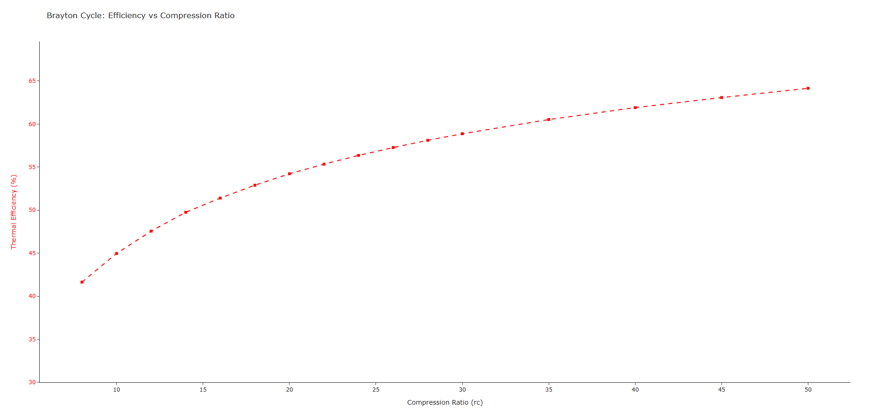

## Conclusion

This Brayton Cycle model accurately calculates performance and provides insights into thermodynamic properties. Can be used for further analysis such as Jet Engine simulation.